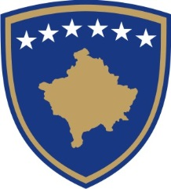

REPUBLIKA E KOSOVËS – PRESIDENTI
REPUBLIC OF KOSOVO – THE PRESIDENT
REPUBLIKA KOSOVO – PREDSEDNIK

AUTHORIZATION ON PERFORMING THE ACTS RELATED TO THE CONCLUSION OF THE INTERNATIONAL AGREEMENT WHICH ENTERS INTO FORCE UPON SIGNATURE

No. _____/----

The President of the Republic of Kosovo,
pursuant to Article 84 of the Constitution of the Republic of Kosovo, Article 6 of Law No. 03/L-094 on the President of the Republic of Kosovo (Official Gazette no. 47, January 25, 2009), and Article 7 (paragraphs 3, 7, 8 and 9) of Law No. 04/L-052 on International Agreements (Official Gazette no. 28, December 16, 2011), and considering the prior Consent of the Ministry of Foreign Affairs on the relevant international agreement and the Decision of the Ministry of Foreign Affairs on the period of the conclusion of the international agreement (xx):

A U T H O R I Z E S
XX Head of the relevant State Agency, to perform the acts related to the conclusion of the international agreement (name of the Agreement), between XXXXX and XXXXX which enters into force upon signature.

____________________________
President of the Republic of Kosovo

Prishtina, on --.---.---

Authorization to be sent to:
- The Minister of the relevant Ministry or the Head of the relevant State Agency;
- The Minister of the Ministry of Foreign Affairs;
- a/a

