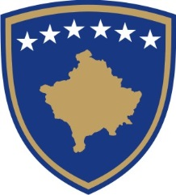

REPUBLIKA E KOSOVËS – PRESIDENTI
REPUBLIC OF KOSOVO – THE PRESIDENT
REPUBLIKA KOSOVO – PREDSEDNIK

AUTHORIZATION ON PERFORMING THE ACTS RELATED TO THE CONCLUSION OF THE INTERNATIONAL AGREEMENT

No. _____/----

The President of the Republic of Kosovo,
pursuant to Article 84 of the Constitution of the Republic of Kosovo, Article 6 of Law No. 03/L-094 on the President of the Republic of Kosovo (Official Gazette no. 47, January 25, 2009), and Article 7 (paragraphs 1, 8 and 9) of Law No. 04/L-052 on International Agreements (Official Gazette no. 28, December 16, 2011), and considering the request of the Government of the Republic of Kosovo (Government Decision No. xx/xx, --.--.-----):

A U T H O R I Z E S
XX Head of the relevant State Agency, to perform the acts related to the conclusion of the international agreement (name of the Agreement), between XXXXX and XXXXX.

____________________________
President of the Republic of Kosovo

Prishtina, on --.---.---

Authorization to be sent to:
- The President of the Assembly of Kosovo;
- The Prime Minister of the Republic of Kosovo;
- The Minister of the relevant Ministry or the Head of the relevant State Agency;
- The Minister of the Ministry of Foreign Affairs;
- a/a

